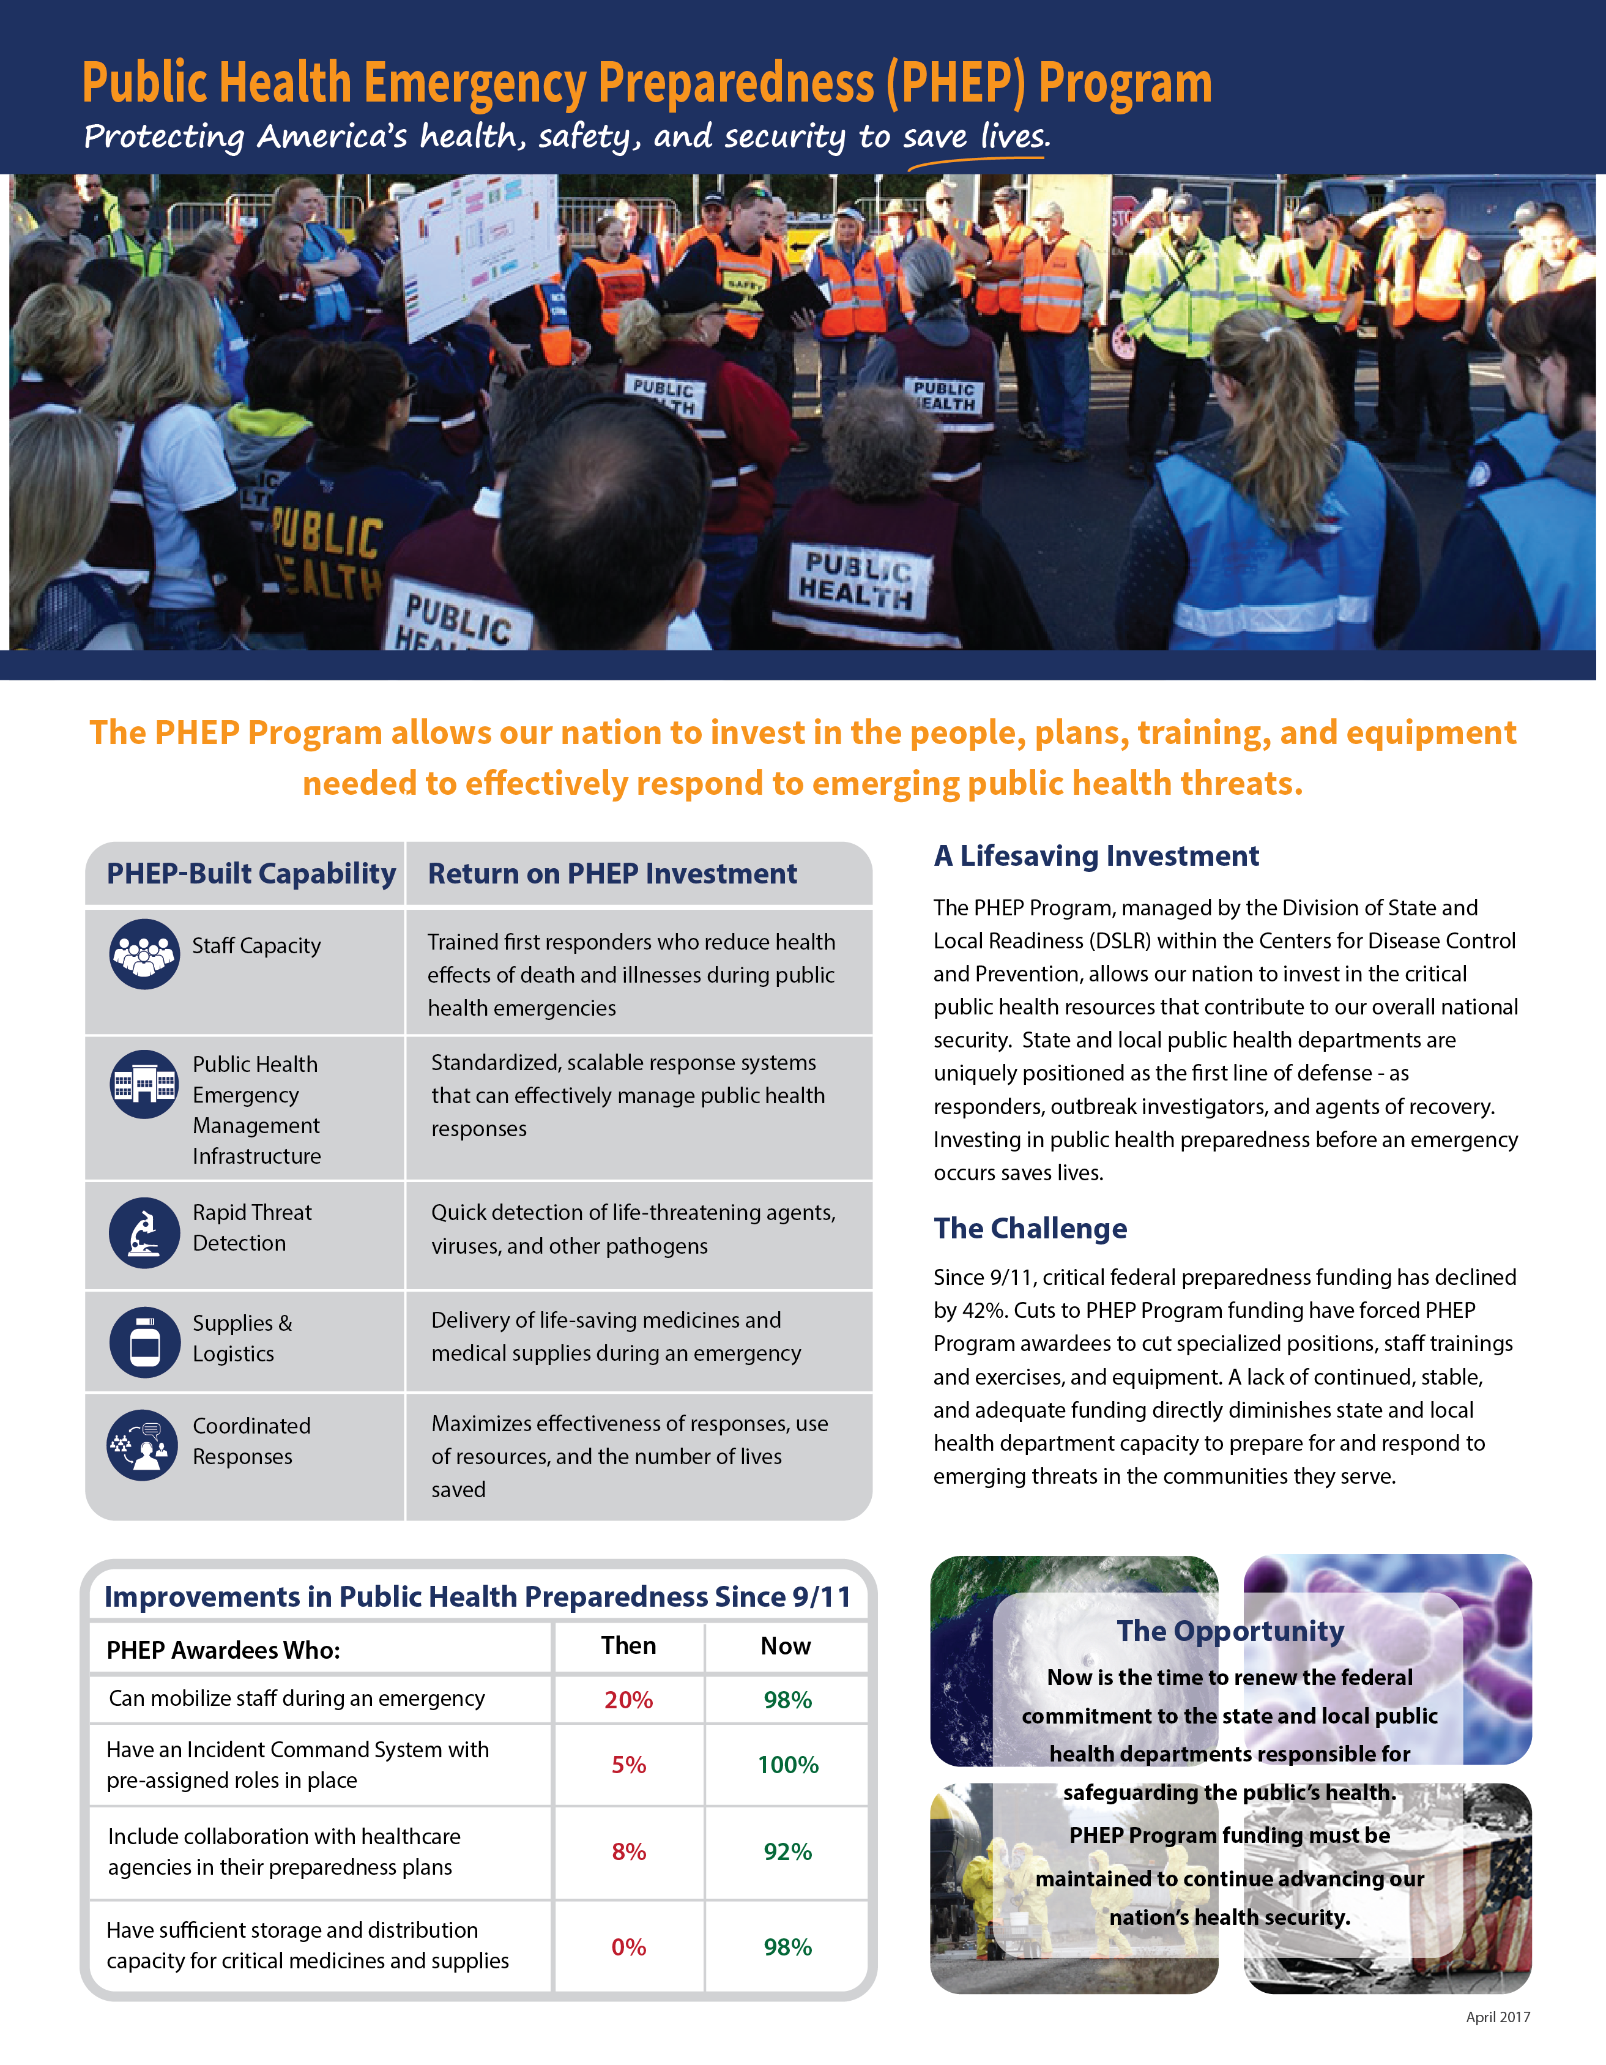

# A closer look: awardee-specific impactStories from the Field

Click here to enter awardee.

## Image of a response supported by the PHEP ProgramEnter the year and name of the event/response (e.g. 2012 Hurricane Sandy)

### Situation

Provide 1-2 sentences explaining what the response or event entailed.

Space

**Intervention**

Provide 1-2 sentences explaining what the PHEP Program provided or allowed your jurisdiction to do to respond to the particular emergency or conduct the event/exercise.

**Impact**

Provide 1-2 sentences explaining the impact in your jurisdiction due to the PHEP Program.

Space

**The PHEP Program in Action**

**Key responses that saved lives due to PHEP Program support:**

|  |  |  |  |
| --- | --- | --- | --- |
| • Year Response | • Year Response | • Year Response | • Year Response |
| • Year Response | • Year Response | • Year Response | • Year Response |
| • Year Response | • Year Response | • Year Response | • Year Response |

**Critical Needs**

**The PHEP Program supports the following public health and safety functions that are jeopardized when funding is cut.**

**Biosurveillance**

Provide 1-2 sentences describing how this public health and safety function would be jeopardized if PHEP funding is cut.

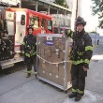**Countermeasures & Mitigation**

Provide 1-2 sentences describing how this public health and safety function would be jeopardized if PHEP funding is cut.

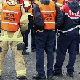**Incident Management**

Provide 1-2 sentences describing how this public health and safety function would be jeopardized if PHEP funding is cut.

**Community Resilience**

Provide 1-2 sentences describing how this public health and safety function would be jeopardized if PHEP funding is cut.

**Information Management**

Provide 1-2 sentences describing how this public health and safety function would be jeopardized if PHEP funding is cut.

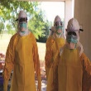**Surge Management**

****Provide 1-2 sentences describing how this public health and safety function would be jeopardized if PHEP funding is cut.