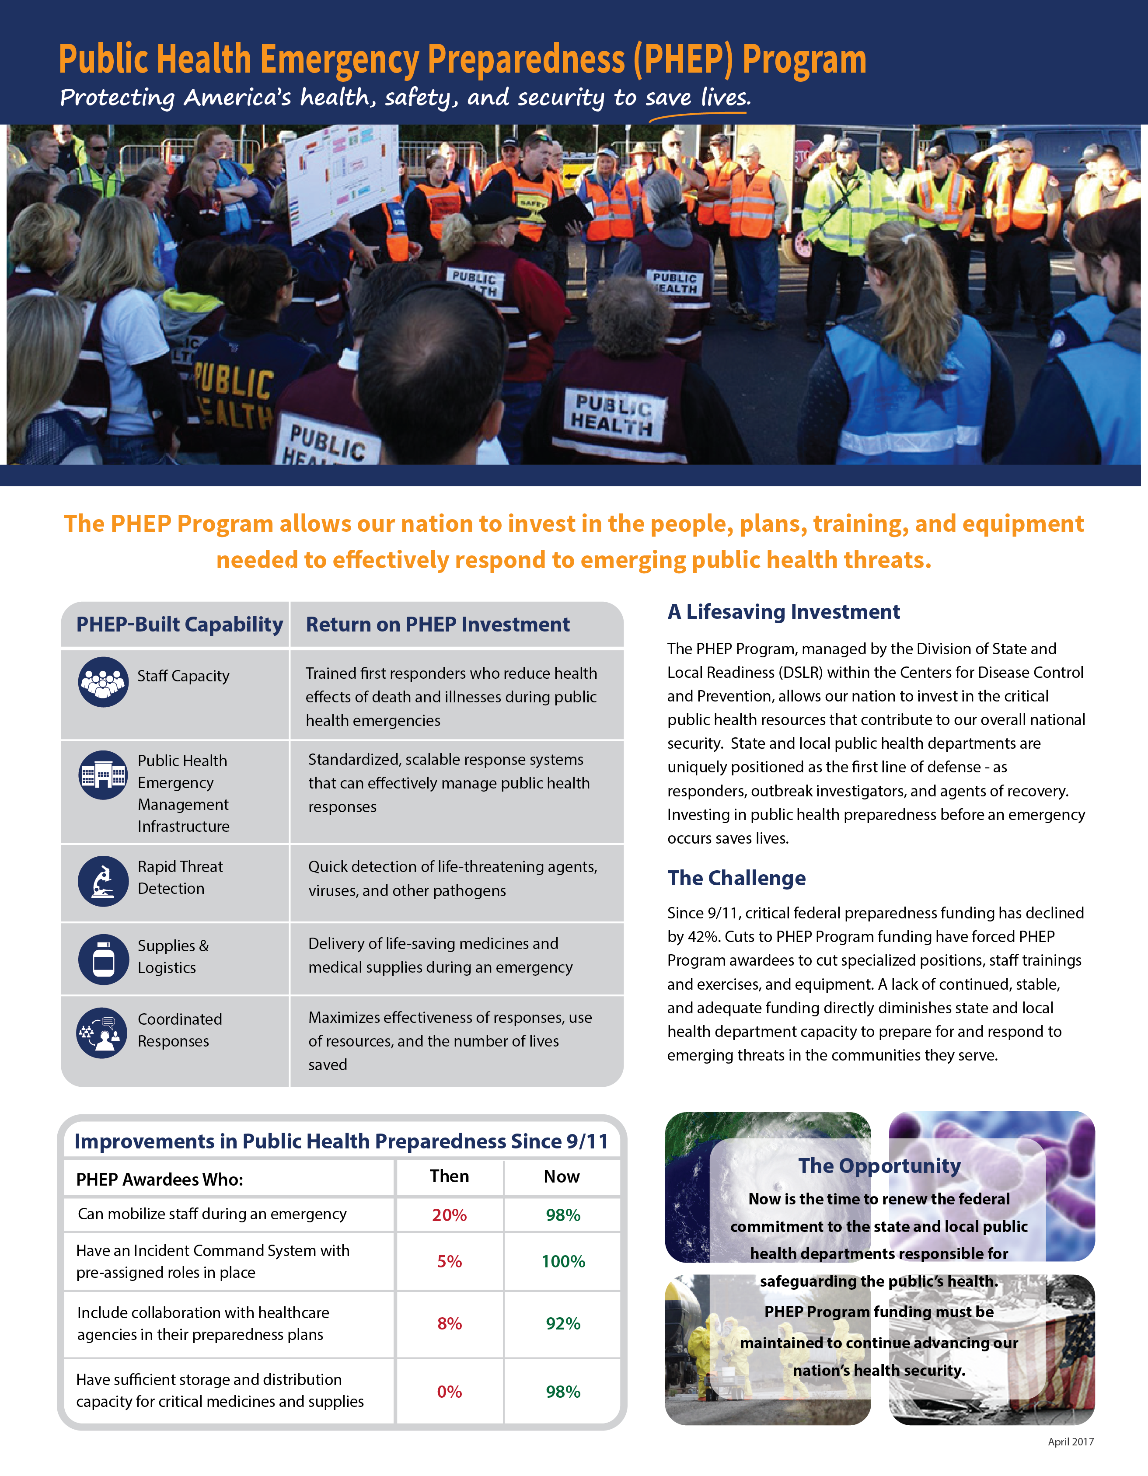

# Image of a response supported by the PHEP ProgramA closer look: awardee-specific impactStories from the Field

# PHEP Program Funding Received

Click here to enter awardee.

## (e.g. 2012 Hurricane Sandy)

### Situation

### 1-2 sentences describing the event/response

**Intervention**

1-2 sentences describing how the PHEP Program allowed you to respond

# The PHEP Program in Action

**Key responses that saved lives due to PHEP Program support:**

|  |  |
| --- | --- |
| • Year Response | • Year Response |
| • Year Response | • Year Response |
| • Year Response  • Year Response | • Year Response  • Year Response |

**Impact**

1-2 sentences explaining the impact of having the PHEP Program when this event/response occurred.

**Critical Needs**

**The PHEP Program supports the following public health and safety functions that are jeopardized when funding is cut.**

**Biosurveillance**

Provide 1-2 sentences describing how this public health and safety function would be jeopardized if PHEP funding is cut.

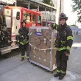**Countermeasures & Mitigation**

Provide 1-2 sentences describing how this public health and safety function would be jeopardized if PHEP funding is cut.

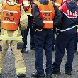**Incident Management**

Provide 1-2 sentences describing how this public health and safety function would be jeopardized if PHEP funding is cut.

**Community Resilience**

Provide 1-2 sentences describing how this public health and safety function would be jeopardized if PHEP funding is cut.

**Information Management**

Provide 1-2 sentences describing how this public health and safety function would be jeopardized if PHEP funding is cut.

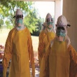**Surge Management**

****Provide 1-2 sentences describing how this public health and safety function would be jeopardized if PHEP funding is cut.